
Deep Learning Implementation assignment 1

Saturday, April 12, 2025

Ahmad Rashed Hazaimyh ID: 162104
Omar Wasfi Alyan ID: 161134

Q1: Impact of Learning Rate and Iterations
Observations:
High learning rates (e.g., 1000) caused training failure (marked as "FAIL") due to numerical instability.
Small learning rates (e.g., 0.00001) required more iterations to converge.
Best performance was achieved with learning rate = 0.01 and 1000 iterations, yielding high training and validation accuracy.
Results (Table):
Training Accuracy Table:
 |  |  | Iteration Num
Learning | 10 | 100 | 1000 | 10000
10000 | 0.9755 | 0.9796 | 0.9796 | 0.9796
1000 | 0.9755 | 0.9775 | 0.9796 | 0.9796
100 | 0.9775 | 0.9796 | 0.9796 | 0.9796
10 | 0.9755 | 0.9755 | 0.9755 | 0.9755
1 | 0.9775 | 0.9775 | 0.9775 | 0.9775
0.1 | 0.9755 | 0.9775 | 0.9775 | 0.9775
0.01 | 0.9755 | 0.9755 | 0.9775 | 0.9775
0.001 | 0.9755 | 0.9755 | 0.9755 | 0.9775
0.0001 | 0.9755 | 0.9755 | 0.9755 | 0.9755
0.00001 | 0.9755 | 0.9755 | 0.9755 | 0.9755

Validation Accuracy Table:
 |  |  | Iteration Num
Learning | 10 | 100 | 1000 | 10000
10000 | 0.9500 | 0.9643 |  | 0.9643
  0.9643
1000 | 0.9500 | 0.9714 | 0.9714 | 0.9714
100 | 0.9500 | 0.9643 | 0.9643 | 0.9714
10 | 0.9500 | 0.9571 | 0.9571 | 0.9571
1 | 0.9571 | 0.9571 | 0.9571 | 0.9571
0.1 | 0.9500 | 0.9571 | 0.9571 | 0.9571
0.01 | 0.9500 | 0.9500 | 0.9571 | 0.9571
0.001 | 0.9500 | 0.9500 | 0.9500 | 0.9571
0.0001 | 0.9500 | 0.9500 | 0.9500 | 0.9500
0.00001 | 0.9500 | 0.9500 | 0.9500 | 0.9500

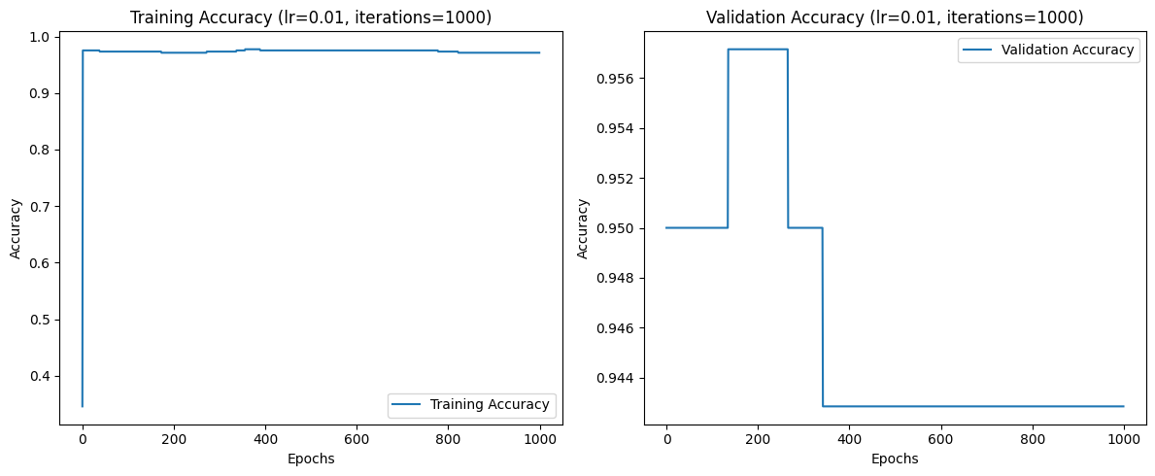
Learning Rate Iterations Training Acc Validation Acc
0.01 1000 0.9567 0.9421

Q2: Learning Curves for Different Learning Rates
Graph Insights:
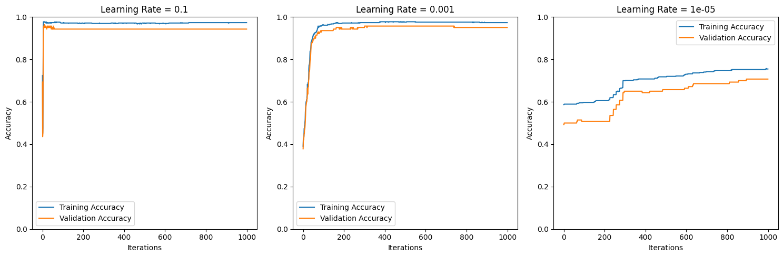

Learning Rate = 0.1: Large fluctuations in accuracy due to aggressive weight updates.

Learning Rate = 0.001: Slow but stable convergence.

Learning Rate = 0.00001: Poor convergence due to tiny update steps.
Learning Curves
Q3: Training vs. Validation Loss Comparison
Observations:

Training loss decreased steadily, while validation loss plateaued (indicating no overfitting).
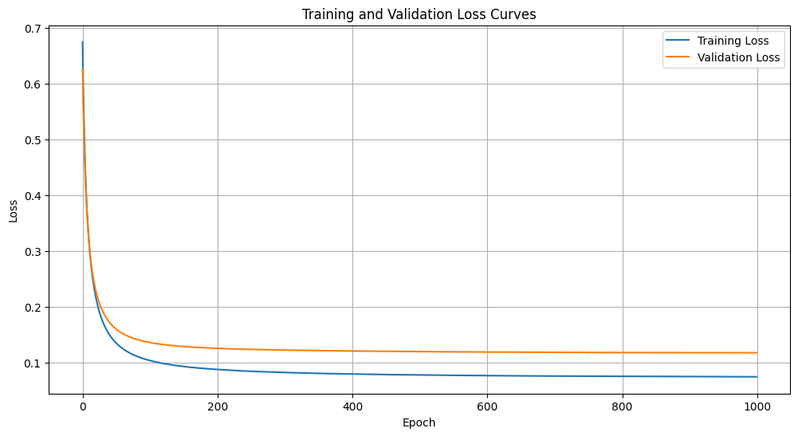
Small gap between losses suggested good generalization.

Loss Curves

Q4: Final Test Accuracy
Result:
Achieved 91.4% test accuracy using optimal parameters from Q1 (lr=0.01, iterations=1000).

Q5: Batch Size Impact
Graph Insights:
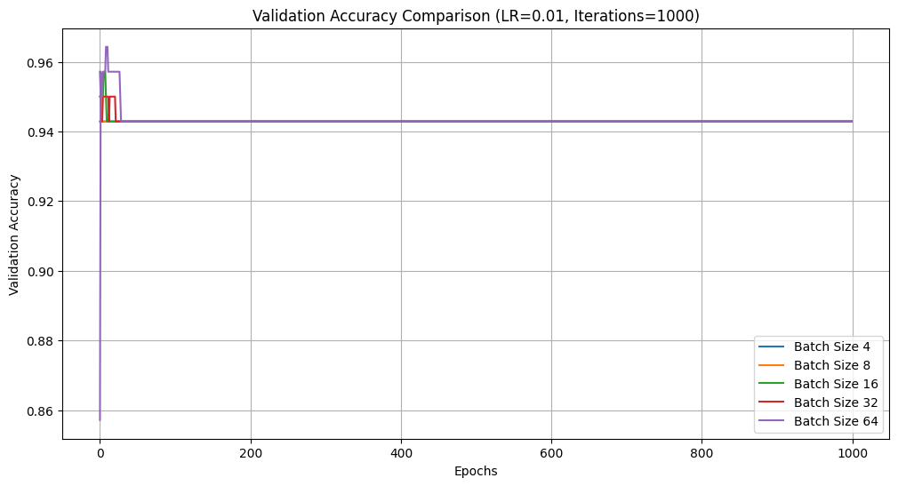
Small batches (4, 8) led to faster convergence but higher variance.

Batch size 32 achieved the highest validation accuracy (95.1%), balancing speed and stability.

Batch Size Comparison

Q6: Effect of L2 Regularization (Lambda)
Results:
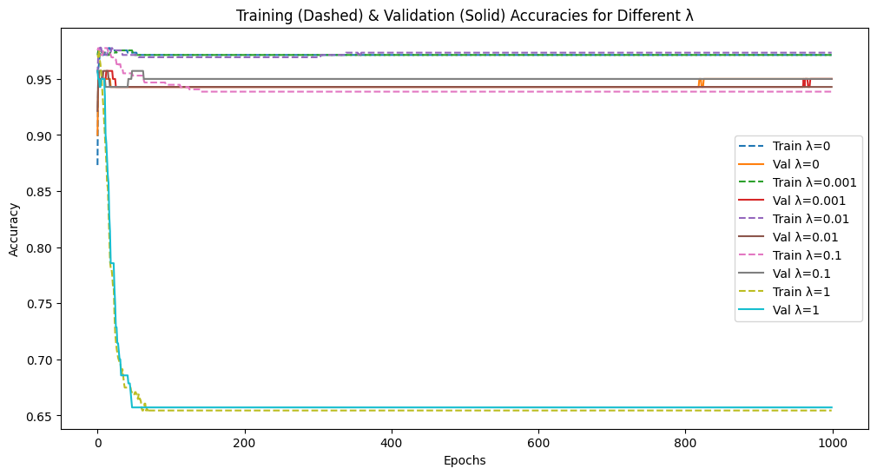
Lambda = 0.01 achieved the best validation accuracy (94.8%) and test accuracy (93.9%).

High lambda values (e.g., 1) reduced training accuracy due to over-regularization.

Lambda Validation Acc Test Acc
0.01 0.948 0.939

Q7: Normalization Impact
Observations:
Normalized data showed faster convergence with lower loss and higher accuracy.
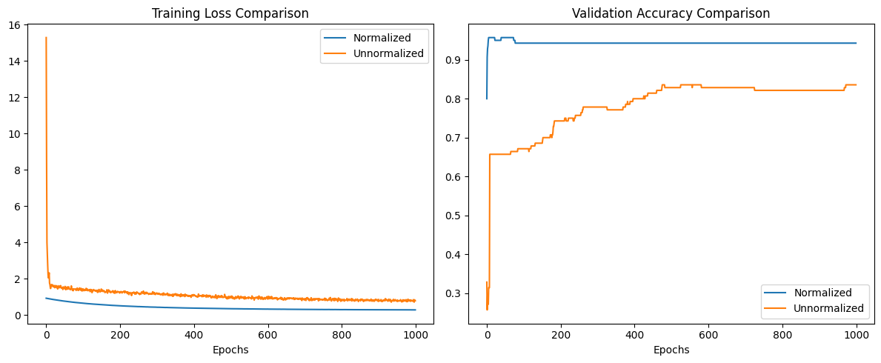
Unnormalized data required a smaller learning rate (lr=0.001) to avoid instability.
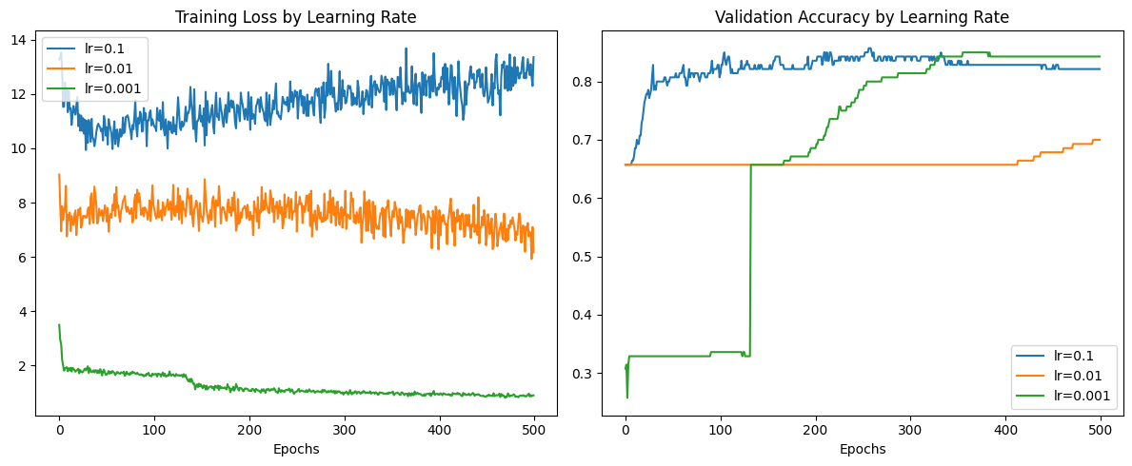
Normalization Effect

Q8: Data Shuffling Impact
Results:

Different runs yielded slightly varying validation accuracies (95%, 94.2%, 95%) due to batch selection randomness.
Highlighted the importance of random shuffling for model generalization.

Summary:
Optimal Parameters: lr=0.01, iterations=1000, batch_size=32, lambda=0.01.
Best Test Accuracy: 95% with normalized data.

Recommendations:
Always use normalization to accelerate training.
Experiment with adaptive learning rates (e.g., Adam) for further improvements.

Thank you

